(Place your IG logo here)

Give yourself a booster shot!
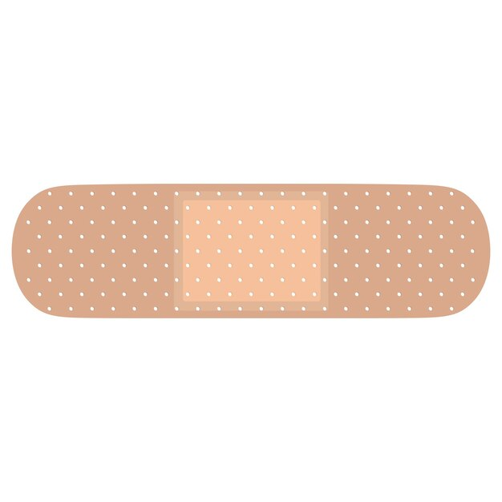
A G E N D A
- 3 Speakers Will Share Their Experience, Strength, and Hope
- Traditions that support giving Service
- Open Sharing
- Free Raffle ($25 gift cert. for OA literature of choice)

(DAY AND DATE) (TIME AND TIME ZONE)

ZOOM INFORMATION: Meeting ID: ___________
Passcode:____________
Or click on the Hyperlink Below:

(PUT ZOOM LINK HERE)___________________________________________________________________

Dial by your location
+(Paste your phone links below)

